

University of Science and Technology Chittagong
Department of Computer Science and Engineering

AI Based Mobile Motion Predictor
Team: Scrolly Sparkles

Publication Type: Project

Course Name: Artificial Intelligence and Expert Systems Lab

Course Code: CSE 324

Semester: 6th

Submitted by:

Name: Taspia Naznin
ID: 23010104
Name: Nusrat Naima Jeny
ID: 23010111

Submitted to:
Topu Biswas
Assistant Professor, CSE, FSET, USTC

Date of Submission: 21st December 2025
ABSTRACT
Project: An AI-based system for predicting gyroscope sensor values from accelerometer data.

Objective: To build a machine learning model for mobile motion prediction.

Method: Linear Regression is applied as a supervised learning technique using accelerometer inputs and gyroscope outputs, evaluated with statistical metrics.

Outcome: The model predicts gyroscope values with acceptable accuracy, demonstrating the usefulness of AI in mobile motion analysis.

Keywords: Mobile sensors, motion prediction, linear regression, machine learning, accelerometer, gyroscope.

- INTRODUCTION
Smartphones are equipped with various motion sensors that generate continuous streams of data. However, accurate interpretation of this data is challenging due to noise, variability, and high sampling frequency. Many real-world applications, such as fitness monitoring, navigation systems, and interactive gaming, rely on precise motion prediction. Therefore, an automated and intelligent approach is required to model and predict motion behavior effectively.
- PROBLEM DESCRIPTION
Smartphone motion sensor data is difficult to analyze manually because of its noisy and complex nature. Traditional approaches are unreliable for accurate prediction. The key challenge lies in learning the relationship between accelerometer and gyroscope data in an efficient and scalable manner. To address this issue, an AI-based solution is proposed to automatically extract patterns from sensor data and perform reliable motion prediction.
III. METHODOLOGY
This work employs a supervised machine learning technique using Linear Regression. Accelerometer values are used as input features, while gyroscope values are considered as output targets. The MotionSense dataset, stored in CSV format, is used for experimentation. The implementation utilizes Python-based tools including Pandas for data processing, Scikit-learn for model training and evaluation, and Matplotlib for result visualization.
IV. IMPLEMENTATION
The system implementation follows a structured workflow. Initially, required Python libraries are imported and the MotionSense dataset is loaded using Pandas. Accelerometer data is selected as the input feature set and gyroscope data as the target output. The dataset is split into training (70%) and testing (30%) subsets. A Linear Regression model is trained using the training data, and predictions are generated on the test data. Finally, actual and predicted values are visualized using a scatter plot.

Step- 01:
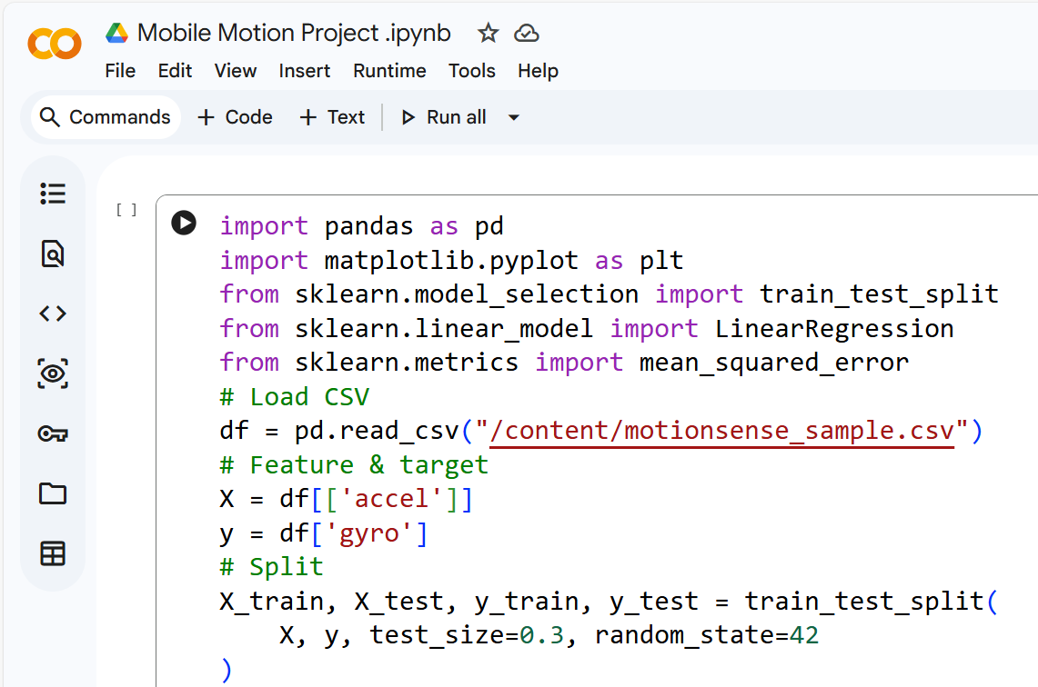

Step-02:
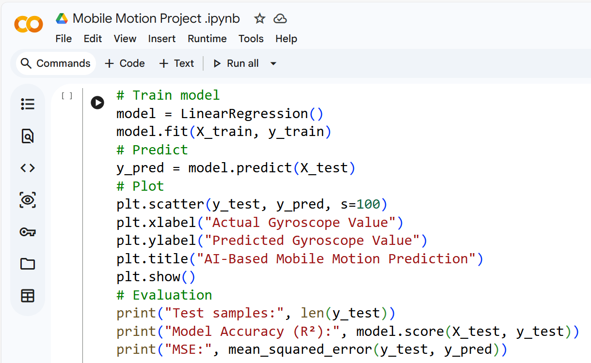

Step – 03:
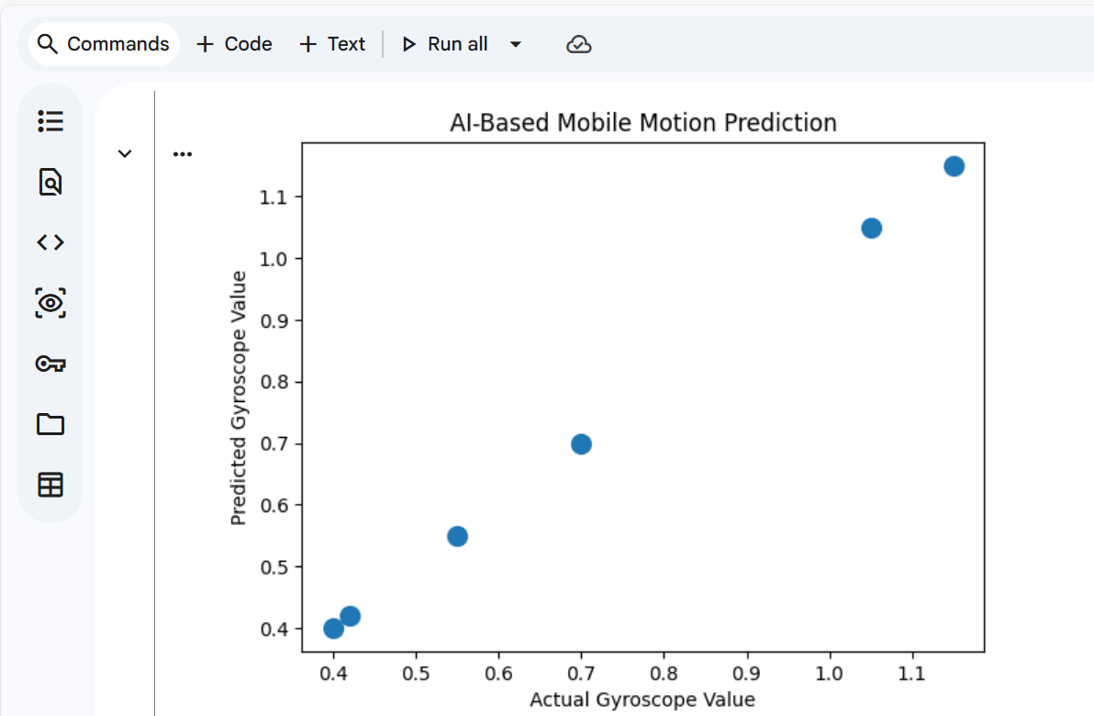

Step – 04:
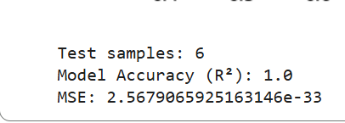

V. MODEL VERIFICATION
Model verification is performed to ensure reliability and consistency. The dataset is validated for missing or invalid values prior to training. A fixed random state is used during data splitting to maintain reproducibility. The trained model exhibits stable behavior with consistent prediction results across executions.

VI. EVALUATION
Model performance is evaluated using statistical metrics such as R² score and Mean Squared Error (MSE). A scatter plot is used to compare actual gyroscope values with predicted values. Results show that points lie close to the diagonal line, indicating good prediction accuracy. Low MSE values confirm that the prediction error is acceptable for a linear model.

VII. CONCLUSION
This project successfully demonstrates an AI-based mobile motion prediction system using Linear Regression. The model achieves reasonable accuracy in predicting gyroscope values from accelerometer data. However, linear regression has limitations in capturing complex non-linear motion patterns. Future work may include the use of advanced machine learning models such as neural networks and the incorporation of multiple sensor features to enhance prediction performance.

VIII. REFERENCES
“Some of the most common supervised machine learning algorithms are:naïve Bayes(NB),K-means clustering,support vector machine(SVM),linear regression,and logistic regression for sensor-based activity prediction tasks.”
(Demrozi ,. F., Pravadelli, Bihorac, & Rashidi, 2020)

Pandas (Data Handling)

👉 https://pandas.pydata.org/docs/

Matplotlib (Graph Plotting)

👉 https://matplotlib.org/stable/tutorials/index.html

Scikit-learn (ML Models)

👉 https://scikit-learn.org/stable/user_guide.html

motionsense_sample.csv:

